Milne, Nikki; Peters, Radd; Buttner, Claire; Longeri, Lauren; Patel, Anoki; Pool, Jan; et al. (2024). Paediatric Spinal Manipulation Taskforce_8. Infographic Scoping Review_FINAL. figshare. Media. https://doi.org/10.6084/m9.figshare.26038741

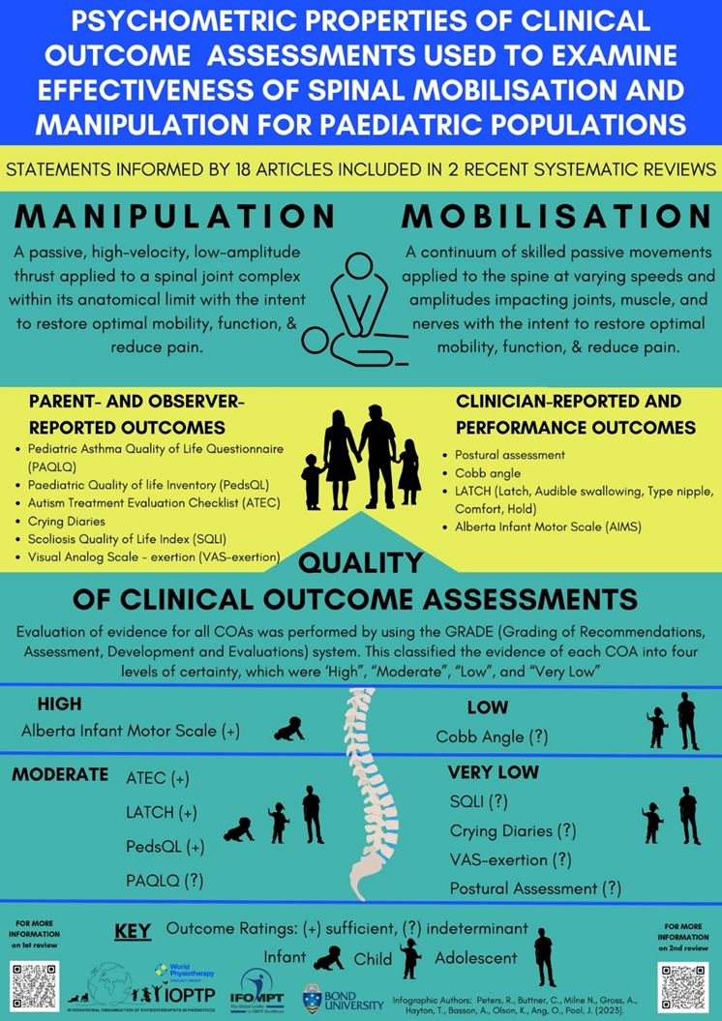

Milne, Nikki; Peters, Radd; Buttner, Claire; Gross, Anita R.; Hayton, Tricia; Basson, Annalie; et al. (2024). Paediatric Spinal Manipulation Taskforce_9. Infographic COAs_FINAL. figshare. Media. https://doi.org/10.6084/m9.figshare.26038789

Milne, Nikki; Gross, Anita R.; Olson, Kenneth; Dice, Jenifer; Brismee, JM; Froment, FP; et al. (2024). Paediatric Spinal Manipulation Taskforce_10. Infographic_Delphi_FINAL. figshare. Media. <https://doi.org/10.6084/m9.figshare.26038831>

Milne, Nikki; Gross, Anita R.; Olson, Kenneth; Pool, Jan; Basson, Annalie; Clewley, Derek; et al. (2024). Paediatric Spinal Manipulation Taskforce_11. Education Infographic no HA_AG_Feb 22 2024_NM_Page 1_FINAL. figshare. Media. https://doi.org/10.6084/m9.figshare.26038921

Key: ADHD = Attention Deficit Hyperactivity Disorder; KISS = Kinetic Imbalance due to Suboccipital Stress; NA = not applicable.

Milne, Nikki; Gross, Anita R.; Olson, Kenneth; Pool, Jan; Basson, Annalie; Clewley, Derek; et al. (2024). Paediatric Spinal Manipulation Taskforce_12. Education Infographic no HA_AG_Feb 22 2024_NM_Page 2_FINAL. figshare. Media. https://doi.org/10.6084/m9.figshare.26038942